Tough Guys Gun & Tough Guys

Hunting Club, Inc. Amusement Square  
 (Indoor Shooting Range)

***Main Office:***    
19 Liberty Ave., Cubao, Quezon City **Tel Fax: 421-6238 / Tel. No. 421-0957**

**CERTIFICATE OF ATTENDANCE**

*****This is to certify that*

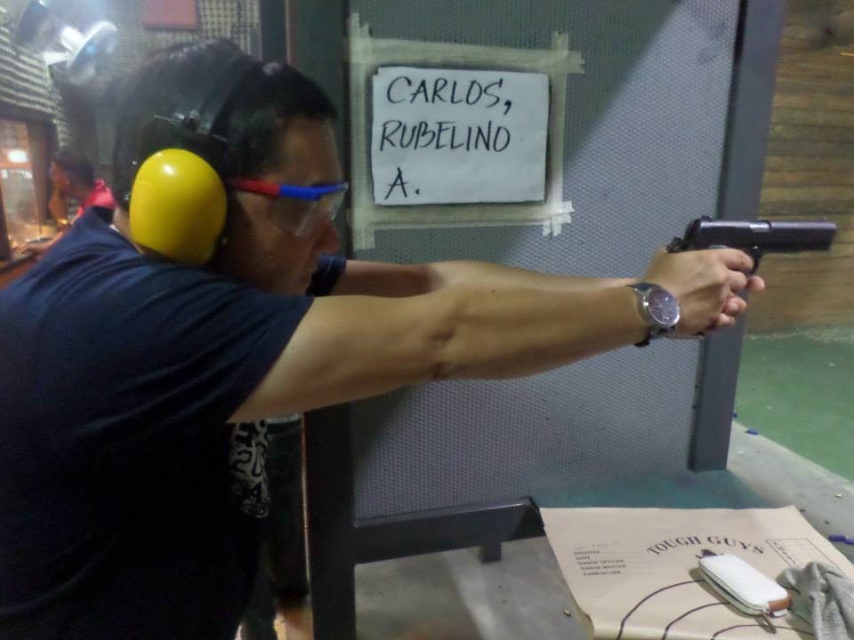has satisfactory passed and completed the **GUN SAFETY AND RESPONSIBLE GUN OWNERSHIP SEMINAR** in accordance with the approved Program of Instruction (POI) pursuant to NAPOLCOM Resolution No. 92-162 dated October 7, 1997 and Implementing Rules and Regulations of Republic Act. No 10591 of 2013, held at:

Place & Address of Seminar: TOUGH GUYS AMUSEMENT SQUARE Q.C

On: Date

Place & Address of Shooting Range: Tough Guys Shooting Range, Quezon City

On: Date

**Issued on: Date at Quezon City.**

**PRECIOUS S. ALMARIO** FEO-06222014-02032R  
 Gun Club President & Instructor

Not Valid Without Seal